CE903 Group Project — Sprint 2

Role 2: ASTRA-sim & Simulation Setup

1. Clone the ASTRA-sim 2.0 Repository
What was done: Cloned the ASTRA-sim 2.0 repository from GitHub including all 7 submodules using the --recurse-submodules flag.
Command used:
git clone --recurse-submodules https://github.com/astra-sim/astra-sim.git
Submodules cloned:
- extern/graph_frontend/chakra — Chakra trace format library
- extern/helper/fmt, spdlog — logging and formatting libraries
- extern/network_backend/analytical — analytical network model
- extern/network_backend/ns-3, csg-htsim — alternative backends (not used)
- extern/remote_memory_backend/analytical — remote memory model

2. Resolve Dependency Issues and Document Them ASTRA-sim is Linux-native. Setup steps vary by OS:
OS | Approach
macOS | Use Homebrew to install dependencies (tested, documented below)
Linux / Ubuntu | Use apt-get instead of brew — all other steps identical
Windows | Must enable WSL2 first, then follow Linux steps inside Ubuntu terminal

Windows — WSL2 Setup (required before anything else):
- Open PowerShell as Administrator and run: wsl --install
- Restart computer, then open the Ubuntu app from Start menu
- Install Miniconda inside WSL2, create conda env p903 (Python 3.11)
- Continue with Linux steps below
macOS — Dependencies installed via Homebrew:
- cmake 4.3.2 — build system
- OpenMPI 5.0.9 — MPI for multi-node simulation
- protobuf 34.1 — Protocol Buffers compiler (protoc)
- coreutils 9.11 — GNU tools including nproc
Linux/Ubuntu — equivalent commands:
sudo apt-get install -y cmake g++ libopenmpi-dev protobuf-compiler
Error 1 (macOS only) — nproc not found
The build script uses nproc (Linux command for CPU count). macOS does not ship nproc by default. Not an issue on Linux or WSL2.
Error 2 (macOS only) — Linker error: symbol(s) not found for architecture arm64
Homebrew protobuf 34.1 (v5.x) requires abseil to be linked separately. The default CMake mode omits abseil, causing the build to fail. Not an issue on Linux where apt-get installs an older compatible protobuf version.
Fix: Set PROTOBUF_FROM_SOURCE=True before building.
export PROTOBUF_FROM_SOURCE=True

3. Run a Bundled Example Workload Successfully
Build command (Linux/WSL2/MacOS):
bash build/astra_analytical/build.sh -t all
Executables produced:
- build/astra_analytical/build/bin/AstraSim_Analytical_Congestion_Unaware
- build/astra_analytical/build/bin/AstraSim_Analytical_Congestion_Aware
Example simulation run:
- Workload: reduce_scatter microbenchmark, 4 NPUs, 1 MB data
- Network: Ring topology, bandwidth 50 GB/s, latency 500 ns
- Algorithm: Ring collective (congestion-unaware backend)
./build/astra_analytical/build/bin/AstraSim_Analytical_Congestion_Unaware \
--workload-configuration=examples/workload/microbenchmarks/reduce_scatter/4npus_1MB/reduce_scatter \
--system-configuration=examples/system/native_collectives/Ring_4chunks.json \
--remote-memory-configuration=examples/remote_memory/analytical/no_memory_expansion.json \
--network-configuration=examples/network/analytical/Ring_4npus.yml

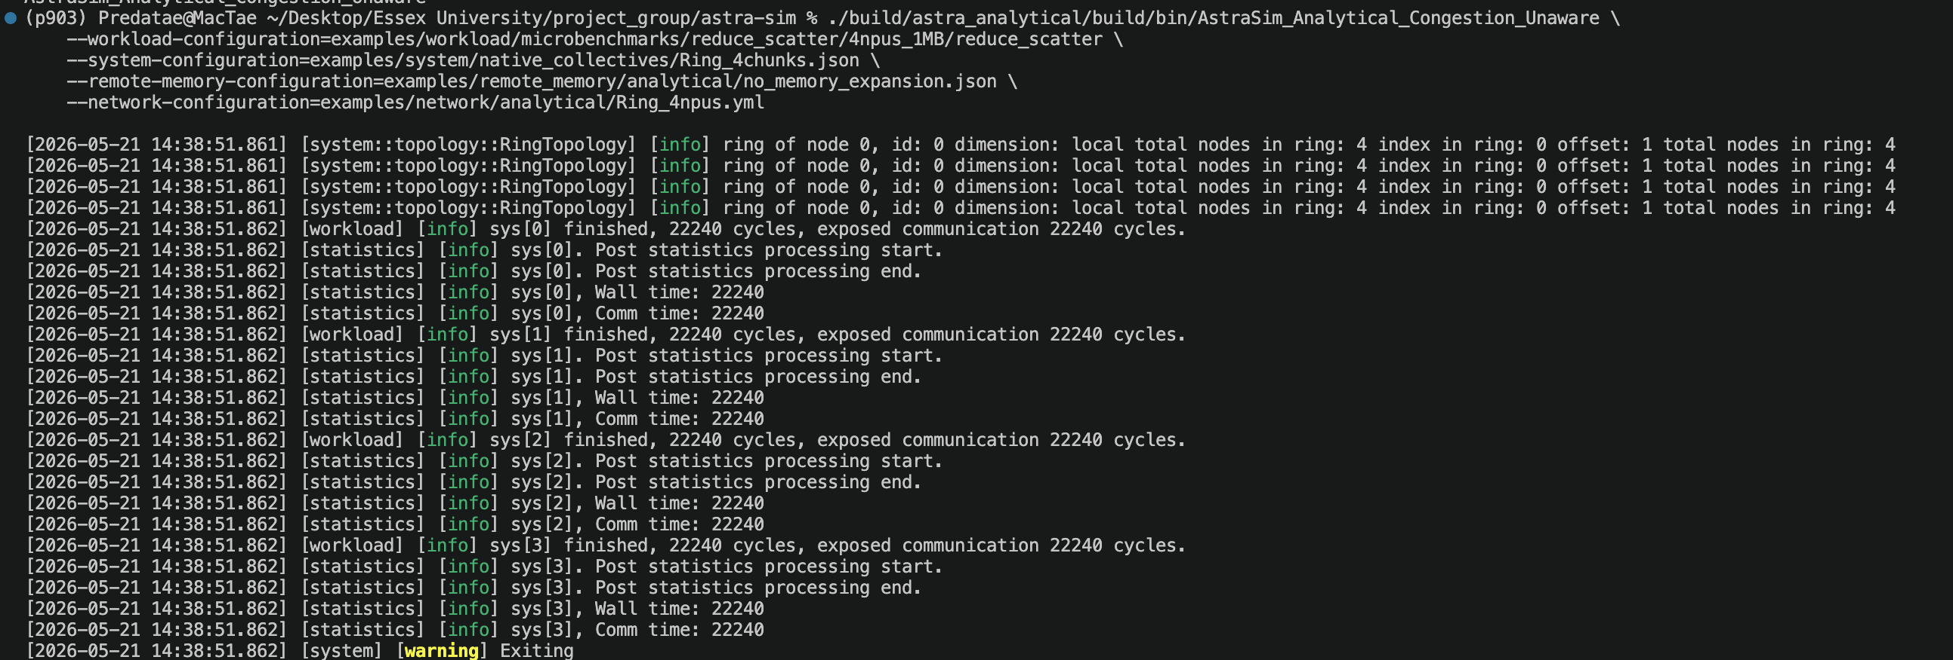
Result: Simulation completed successfully. All 4 NPUs finished in 22,240 cycles.

4. Record What Outputs Are Produced and What They Represent
Output files generated:
- log/log.log — Main simulation results per NPU
- log/err.log — Error log (empty = clean run
Simulation results (reduce_scatter, 4 NPUs, Ring, 50 GB/s):
NPU | Wall Time (cycles) | Comm Time (cycles)
sys[0] | 22,240 | 22,240
sys[1] | 22,240 | 22,240
sys[2] | 22,240 | 22,240
sys[3] | 22,240 | 22,240

Wall time = total simulated time from start to finish for that NPU.
Comm time = time spent in network communication. Equal to Wall time here because this is a pure communication microbenchmark with no compute workload.

5. Brief Note on Loading Custom Chakra Traces
Chakra traces (.et files) are binary protobuf files that encode the execution trace of a training workload — what each GPU does, in what order, and how much data it sends.
Naming convention:
One .et file is required per NPU, named with a shared prefix followed by the NPU index:
/path/to/my_workload.0.et ← NPU 0
/path/to/my_workload.1.et ← NPU 1
...
/path/to/my_workload.N-1.et ← NPU N-1

To run with custom traces:
./AstraSim_Analytical_Congestion_Unaware --workload-configuration=/path/to/my_workload ...
Generating traces from Hugging Face training:
- Install Chakra tools: pip install -e extern/graph_frontend/chakra
- Run PyTorch training with Chakra hooks enabled to export .et files automatically
- See extern/graph_frontend/chakra/README.md for full instructions

